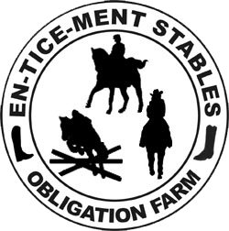
EN-TICE-MENT STABLES, LLC
at Obligation Farm 4016 Solomons Island Rd Harwood, MD 20776
www.enticementstables.com or enticementstables@msn.com or 410-798-4980

2020 Kid’s Equestrian Camps

We offer small private groups to teach the children equestrian skills in a fun family atmosphere. We teach the children every aspect of horsemanship from riding to the total care of the horse. We also offer some non-equestrian activities for the children’s total enjoyment. Our camps are certified by the State of Maryland. For children ages 5 - 7 we offer a 1/2 day camp. All of our camps are for beginners to intermediate level. The Camp in June offers a program for advanced intermediate and beginner riders.
On Friday during summer camp we will hold demonstrations for the kids to show off their new skills. These will be held at 3pm. Parents, guardians, family and friends are encouraged to attend.
Camp fees:
$400. per week all day camp 8:30am- 4:30pm-pay by March 15th $350-pay by May 1st $375.
$250. per week 1/2 day camp 8:30am-noon-pay by March 15th $225.-pay by May 1st $240.
Holiday fees: $80.00 per day 8:30 - 4:30
$50.00 per ½ day 8:30 - noon
Camp Dates for 2020-
April 9th & 10th ⁻ Spring Break camp -(all levels)
June 22nd – 26th - (Advanced, intermediate & beginner riders)
July 6th – 10th - (all levels)
July 20th – 24th - (all levels)
August 3rd – 7th - (all levels)
August 17th – 21st – (all levels)

General info: Riding attire is long pants or chaps and boots or hard sole shoes with a heel. We suggest you bring your own helmet. Please bring shorts, tennis shoes ( no flip flops or sandals) or comfortable clothes when not riding. Our other activities may include painting so wear old clothes. Other things to bring - Lunch, lots of drinks/water or change for soda machine & sunscreen.

